# CS 499 Module One Assignment Template

Complete this template by replacing the bracketed text with the relevant information.

1. **Self-Introduction:** Address all of the following questions to introduce yourself.
   1. How long have you been in the Computer Science program?

**I have been in the Computer Science program for over three years. During this time, I have completed a range of courses that have provided me with both foundational knowledge and hands-on experience in a variety of technical disciplines.**

* 1. What have you learned while in the program? List three of the most important concepts or skills you have learned.

**The three most important concepts I have learned are algorithms and data structures, database management (including both SQL and NoSQL), and full-stack web development. These areas form the foundation of many computer science applications and have helped me solve real-world problems effectively. Additionally, I’ve gained an appreciation for modern trends such as artificial intelligence and software engineering principles like modularity, scalability, and maintainability.**

* 1. Discuss the specific skills you aim to demonstrate through your enhancements to reach each of the course outcomes.

**Through my planned enhancements, I aim to demonstrate several critical skills. These include designing efficient and scalable software architectures using industry best practices, optimizing algorithms for better time and space complexity, and implementing secure and optimized data handling strategies using both relational and non-relational databases. These enhancements will allow me to showcase my ability to plan, implement, and improve professional-level software solutions aligned with course outcomes.**

* 1. How do the specific skills you will demonstrate align with your career plans related to your degree?

**The skills I plan to demonstrate are directly aligned with my career goal of becoming a senior software engineer. I intend to specialize in backend development and system architecture, so my enhancements will reflect my ability to write modular code, solve complex problems efficiently, and design robust database solutions—all of which are essential skills for the career path I am pursuing.**

* 1. How does this contribute to the specialization you are targeting for your career?

**These enhancements contribute to my targeted specialization by reinforcing my experience in full-stack and backend development. They also illustrate my ability to manage software complexity, maintain data integrity, and optimize performance—all necessary for designing enterprise-grade systems. Furthermore, the focus on security and maintainability aligns with current industry demands and trends.**

1. **ePortfolio Set Up:**
   1. Submit a **screen capture** of your ePortfolio GitHub Pages home page that clearly shows your URL.
      1. You already have a repository in GitHub where you uploaded projects in previous courses. Your ePortfolio will reside in GitHub but can link to work at other sites, such as Bitbucket.
   2. Use the GitHub Pages link in the Resource section for directions on:
      1. How to create your GitHub website and publish code to GitHub Pages
      2. Issues, such as adding links to other sites
   3. Paste a screenshot of your GitHub Pages home page with your URL clearly showing in the space below.

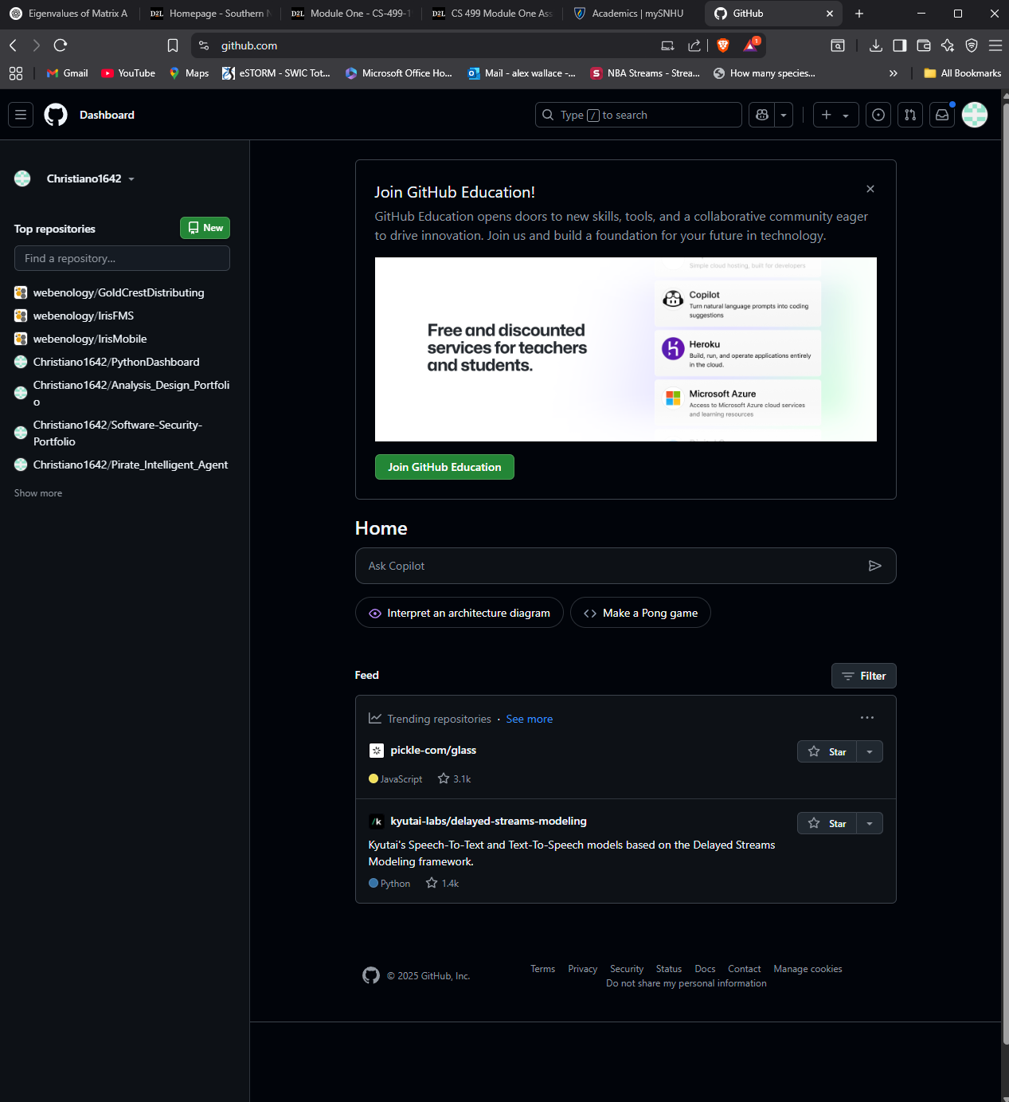

1. **Enhancement Plan:** 
   1. **Category One:** Software Engineering and Design
      1. **Select an** **artifact** that is **aligned with** **the** software engineering and design **category** and explain its origin. Submit a file containing the code for the artifact you choose with your enhancement plan.

**The artifact I have selected is an inventory management application that I built in IT 315: Object-Oriented Analysis and Design. The system allows for basic CRUD operations and was originally built using C# and ASP.NET Core. It is a strong representation of software design principles in action and provides a solid foundation for further enhancement.**

Note: Your artifact may be work from the following courses:

* IT 145: Foundation in Application Development
* CS 250: Software Development Lifecycle
* CS 260: Data Structures and Algorithms
* IT 315: Object Oriented Analysis and Design
* CS 320: Software Testing, Automation, and Quality Assurance
* CS 330: Computational Graphics and Visualization
* CS 340: Advanced Programming Concepts
* CS 350: Emerging Systems Architectures and Technologies
* CS 360: Mobile Architecture and Programming
* IT 365: Operating Environments
* IT 380: Cybersecurity and Information Assurance
* CS 405: Secure Coding
* CS 410: Reverse Software engineering
* IT 340: Network and Telecommunication Management
* IT 380: Cybersecurity and Information Assurance
  + 1. **Describe** a practical, well-illustrated **plan** for enhancement in alignment with the category, including a pseudocode or flowchart that illustrates the planned enhancement.

**My enhancement plan involves refactoring the service and controller layers using proper dependency injection and applying the SOLID principles. I will extract business logic into services, improve middleware for centralized error handling, and update the UI with responsive design improvements. The pseudocode for this enhancement is as follows:**

START

|__ Define interface IInventoryService

|__ Implement InventoryService class

|__ Register IInventoryService in Startup.cs

|__ Inject IInventoryService into InventoryController

END

* + 1. Explain how the planned enhancement will **demonstrate** specific **skills** and align with course outcomes.
       1. Identify and describe the specific skills you will demonstrate that align with the course outcome.

**This enhancement demonstrates my ability to design modular and maintainable systems using object-oriented design principles. It also shows the practical application of dependency injection, separation of concerns, and error handling. These align with course outcomes that involve designing computing solutions using best practices and implementing software that meets industry goals.**

* + - 1. Select one or more of the course outcomes below that your enhancement will align with.

**Design and evaluate computing solutions that solve a given problem using algorithmic principles and computer science practices and standards appropriate to its solution while managing the trade-offs involved in design choices.**

**Demonstrate an ability to use well-founded and innovative techniques, skills, and tools in computing practices to implement computer solutions that deliver value and accomplish industry-specific goals.**

Course Outcomes:

1. Employ strategies for building collaborative environments that enable diverse audiences to support organizational decision-making in the field of computer science.
2. Design, develop, and deliver professional-quality oral, written, and visual communications that are coherent, technically sound, and appropriately adapted to specific audiences and contexts.
3. Design and evaluate computing solutions that solve a given problem using algorithmic principles and computer science practices and standards appropriate to its solution while managing the trade-offs involved in design choices.
4. Demonstrate an ability to use well-founded and innovative techniques, skills, and tools in computing practices for the purpose of implementing computer solutions that deliver value and accomplish industry-specific goals.
5. Develop a security mindset that anticipates adversarial exploits in software architecture and designs to expose potential vulnerabilities, mitigate design flaws, and ensure privacy and enhanced security of data and resources.
   1. **Category Two:** Algorithms and Data Structures
6. **Select an artifact** that is **aligned with the** algorithms and data structures **category** and explain its origin. Submit a file containing the code for the artifact you choose with your enhancement plan. You may choose work from the courses listed under Category One.

**The artifact I selected is a pathfinding visualizer that I created in CS 260: Data Structures and Algorithms. The original project implemented Dijkstra’s algorithm to visually display the shortest path between two points in a grid layout.**

1. **Describe** a practical, well-illustrated **plan** for enhancement in alignment with the category, including a pseudocode or flowchart that illustrates the planned enhancement.

**My enhancement plan is to implement the A* pathfinding algorithm, which improves performance through the use of heuristics. I also plan to refactor the algorithm and data structure logic into separate modules to improve maintainability. The pseudocode is as follows:**

function AStar(start, goal):

openSet = priority queue containing start node

while openSet not empty:

current = node in openSet with lowest fScore

if current == goal:

return reconstructPath()

remove current from openSet

for each neighbor:

temp_gScore = gScore[current] + dist(current, neighbor)

if temp_gScore < gScore[neighbor]:

cameFrom[neighbor] = current

gScore[neighbor] = temp_gScore

fScore[neighbor] = gScore[neighbor] + heuristic(neighbor, goal)

if neighbor not in openSet:

add neighbor to openSet

1. Explain how the planned enhancement will **demonstrate** specific **skills** and align with course outcomes.
   1. Identify and describe the specific skills you will demonstrate to align with the course outcome.

**This enhancement shows my understanding of algorithm efficiency and heuristic design. It also demonstrates my ability to refactor and scale logic for more complex implementations. The enhancement reflects my capability to evaluate trade-offs in design and apply best-fit algorithmic solutions to improve system performance.**

* 1. Select one or more of the course outcomes listed under Category One that your enhancement will align with.

**Design and evaluate computing solutions that solve a given problem using algorithmic principles and computer science practices and standards appropriate to its solution while managing the trade-offs involved in design choices.**

**Demonstrate an ability to use well-founded and innovative techniques, skills, and tools in computing practices for the purpose of implementing computer solutions that deliver value and accomplish industry-specific goals.**

* 1. **Category Three: Databases**
     1. **Select an artifact** that is **aligned with the** databases **category** and explain its origin. Submit a file containing the code for the artifact you choose with your enhancement plan. You may choose work from the courses listed under Category One.

**The selected artifact is a MongoDB-backed dog adoption platform built in CS 340: Advanced Programming Concepts. The application allows users to view, add, and manage dog profiles and includes basic CRUD operations.**

* + 1. **Describe** a practical, well-illustrated **plan** for enhancement in alignment with the category, including a pseudocode or flowchart that illustrates the planned enhancement.

**I plan to implement MongoDB aggregation pipelines for data analysis and add user authentication to restrict sensitive endpoints. The database schema will also be optimized by normalizing repeated structures and adding indexes for performance. The pseudocode for the aggregation pipeline is:**

db.dogs.aggregate([

{ $match: { status: "available" } },

{ $group: {

_id: "$breed",

count: { $sum: 1 }

}

},

{ $sort: { count: -1 } }

])

* + 1. Explain how the planned enhancement will **demonstrate** specific **skills** and align with course outcomes.
       1. Identify and describe the specific skills you will demonstrate that align with the course outcome.

**This enhancement shows my ability to manage and optimize NoSQL databases, implement data aggregation techniques, and secure data endpoints. These are all essential skills in modern database development and align well with outcomes related to designing secure and efficient computing solutions.**

* + - 1. Select one or more of the course outcomes listed under Category One that your enhancement will align with.

**Demonstrate an ability to use well-founded and innovative techniques, skills, and tools in computing practices for the purpose of implementing computer solutions that deliver value and accomplish industry-specific goals.**

**Develop a security mindset that anticipates adversarial exploits in software architecture and designs to expose potential vulnerabilities, mitigate design flaws, and ensure privacy and enhanced security of data and resources.**

1. **ePortfolio Overall Skill Set**
   1. Accurately describe the **skill set** to be illustrated by the **ePortfolio** **overall**.
      1. Skills and outcomes planned to be illustrated in the code review

**The ePortfolio will highlight a range of skills, including full-stack software development, secure coding practices, algorithmic optimization, and both relational and non-relational database management. It will demonstrate my ability to take a project from initial concept to a refined, deployable product using industry-standard tools and techniques. In the code review sections, I plan to illustrate my ability to write clean, modular code following design principles such as SOLID and DRY. I will also showcase enhancements to algorithms and database queries that improve system performance, accuracy, and maintainability.**

* + 1. Skills and outcomes planned to be illustrated in the narratives

**The narratives will provide context for each enhancement, explaining the rationale behind the changes and the benefits achieved. They will demonstrate my ability to communicate technical decisions clearly and justify them based on performance, scalability, and security considerations.**

* + 1. Skills and outcomes planned to be illustrated in the professional self-assessment

**The professional self-assessment will showcase my growth throughout the Computer Science program, reflect on how my projects align with industry practices, and outline how the skills I’ve demonstrated have prepared me for a successful career in software development.**